COQ Electronic Submission Guidelines

For NAHMA’s Communities of Quality (COQ) Applications
(Document date: April 22, 2013)

Communities of Quality (COQ) Applications are divided into the following parts:

- Application form
- Category 1 - Inspections
- Category 2 - Financial Management
- Category 3 - Employee Credentials
- Category 4 - Programs and Services
- Category 5 - Endorsements
- Category 6 - Photographs and Reports

How to Submit an Electronic COQ Application (acceptable formats):

The following are considered acceptable submission formats:

- USB Flash Memory, CD or DVD - Applications can be submitted in this fashion with the files clearly specifying the property as well as the name of the files.
- Email - Applications will be accepted as attachments sent in e-mail transmission(s). (The size of the attached PDFs may require them to be sent via multiple emails.) Use of compression technology such as WinZIP is highly recommended but not required.
** Please note: Hard/Paper copies are not acceptable.

How to Prepare the COQ Application in Electronic Format:

The COQ Application will be made in the form of 7 different electronic (digital) files (representing the 7 parts of the application, as described above). Acceptable file formats include pdf, tif, and jpg.

- Application Contact Information
All documents supporting each of the following categories should be included in each file:
- Category 1 - Inspections
- Category 2 - Financial Management
- Category 3 - Employee Credentials
- Category 4 - Programs and Services
- Category 5 - Endorsements
- Category 6 - Photographs and Reports

Where to Send your Electronic COQ application:

By mail:
Your local AHMA postal address

By e-mail
Your local AHMA email

**You should contact your local AHMA to verify their preferred form of submission

Please name each of the eight files that represent your complete electronic COQ submissions by referencing the Property Name and the category of the application.

Examples:
Westfield Apts. – App - This is the Application Contact Information Sheet and should include the Point Summary Shart.
Westfield Apts. – Cat 1 – This is the submission for the Inspection Category
Cook Towers – Cat 3 – This is the submission for the Employee Credentials Category

The following is a sample of a processed application, for apartment complex Baptist Retirement Village, after you submit it to your local AHMA:

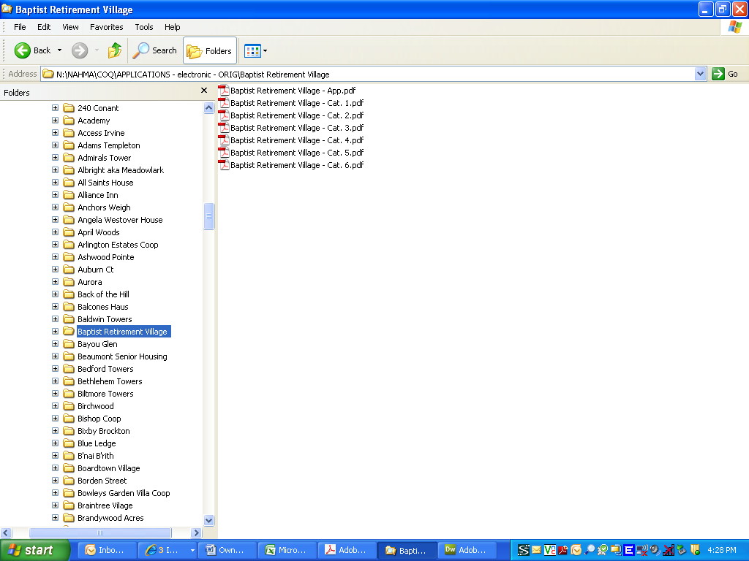

How to Submit your COQ Application Fee and Approval Process:

- When the property submits an electronic COQ application to its AHMA, it should include a check payable to the AHMA in the amount of $150 for the COQ application fee. (The application fee is $150 for members of NAHMA or an AHMA, or $325 for non-members.) Please note: Please check with your AHMA to see if they accept credit card payments. Credit card payments may be made using the COQ application invoice.
- The AHMA will then review and verify the application is correctly compiled and completed, and that the check has been submitted in the correct amount.
- When the AHMA has confirmed everything is correct, it will forward the application to NAHMA.
- NAHMA will review and approve the application and publish the new COQ property to the NAHMA online COQ directory (at http://www.nahma.org/acoappCoq/COQSearch.cfm). In addition, a confirmation email will be sent and congratulations packet will be shipped to the new COQ property.

