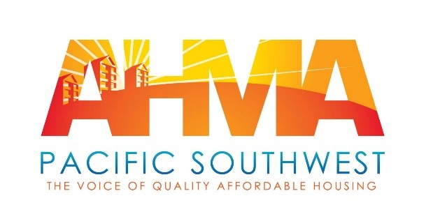

Office of the General Counsel, Regulations Division
Dept. of Housing and Urban Development
Submitted via Regulations.gov

RE: Docket No. FR-6160-N-101

To Whom it May Concern

We would like to thank you for the opportunity to submit comments on the above docket, also known as the National Standards for the Physical Inspection of Real Estate (NSPIRE) Demonstration proposed by the US Dept. of Housing and Urban Development (HUD).

The overall premise of this new model is flawed, and this needs to be addressed at the outset. This change is not needed due to the age of the existing REAC protocol, the changing nature of the portfolio, nor the interest of some property owners in “meeting minimal compliance thresholds (rather than) incorporating best practices that relate to property maintenance”. The fact is the vast majority of properties score well above minimum compliance every time (including when the protocol was first introduced) and there is consensus that the protocol actually interferes with our ability to maintain best practices due to subjective standards and constantly changing areas of emphasis. The inclusion of PHAs and Owner/Agents (POAs) in the pilot program to help develop accurate and high quality inspections which yield tangible and beneficial results.

Moving on to the issue at hand, the Notice is accurate in stating many PHAs and Owner/Agents (POAs) already have a contractual obligation to inspect 100% of our assisted units each year. As a matter of sound business we would be foolish not to with or without this obligation. However, we currently use our own forms and methodologies when conducting these inspections to give us the information that we need to not only adequately maintain the units, but also to conduct lease enforcement activities when Residents are creating damages beyond normal wear and tear. Without the ability to see the form or software in question, I believe it is reasonable to assume this will be based on the current UPCS-V model, which while helpful, reflects the information needs of a subsidy provider, not of a property owner or manager. This 100% inspection and work order reporting on an annual basis will pose an enormous time burden, and will yield no tangible results. The fact is those POAs which are currently doing a substandard job, and who truly do only prepare for inspections with no maintenance in between are not likely to be more reliable with self reporting. Since REAC has made it clear that they do not even trust a high percentage of their own contract inspectors and QA inspectors, why do they now put so much trust in the industry? In addition it is difficult to imagine that HUD has sufficient resources to review every inspection and work order on every unit in the country when they have not even been able to update the plethora of expired forms they are forcing the industry to use in violation of federal law. In the end this will be an additional IT expense and will be an enormous investment in time with no positive outcome probable.

Another of the stated goals is to make inspections more objective. From the proposed protocols that have been posted to date this goal is not being met. An objective inspection is very straightforward, and actually should require no actual protocol at all. The current HQS inspection, which is on the way to being replaced is a much better method of objective inspection. HQS consists mainly of questions revolving around is it there, and does it work. For example: “Is there a door? Does it open? Does it close and latch? For exterior doors does it lock? Is it weathertight?” This is completely objective and gages the safety and security of the home. Are there non industry standard repairs addresses appeal, not function. Does the knob wiggle is subjective. Keep it simple to address the function, not the appeal. While high quality affordable housing is the goal, housing that is safe and sanitary but not pretty is far superior to no housing. It is laudable that REAC has been transparent thus far in posting the proposed protocol, but the premise is so badly flawed that nothing will be accomplished unless the overall approach is changed.

Shifting the inspection focus by giving higher weight to unit interior scores is a move in the right direction. As stated by REAC this is where the people live, so these are the conditions that most effect their daily lives. Failing to provide functioning plumbing, appropriate HVAC, allowing a condition that creates mold to continue, failing to address infestations are just not acceptable. However, many conditions that exist inside of a unit that create health, safety or sanitary issues are created by the Resident. The industry is consistently told this is our fault because we are not enforcing our leases. However, in the end it is the judicial system, not the POAs which enforce the lease and many judges simply refuse to do so. If a deficiency is clearly caused by the Resident any new inspection protocol should have the ability to note this so that we have a better ability to encourage changes to behavior, and take appropriate action if the behaviors do not change.

Thank you for the opportunity to comment.

Sincerely

AHMA-PSW

Anthony Sandoval, President

Kurt Aldinger, Vice President Legislative and Regulatory Affairs

Jazmin Ceballos, Executive Director

